This URL documents MovieDB's bearer authentication method:
https://developers.themoviedb.org/3/getting-started/authentication

The HTTP authorization header for a bearer token must have the token given to you when requested an API key.
Paste your bearer token into your appsettings.json file:

{
"Logging": {
"LogLevel": {
"Default": "Information",
"Microsoft": "Warning",
"Microsoft.Hosting.Lifetime": "Information"
}
},
"ApiKeys": {
"MovieAPI": "Your API key goes here"
},
"ApiBearerTokens": {
"MovieDbBearerToken": "Your Bearer Token goes here"
},
"ConnectionStrings": {
"DefaultConnection": "Server=.\\SQLEXPRESS;Database=MovieDb;Trusted_Connection=True;"
}
}

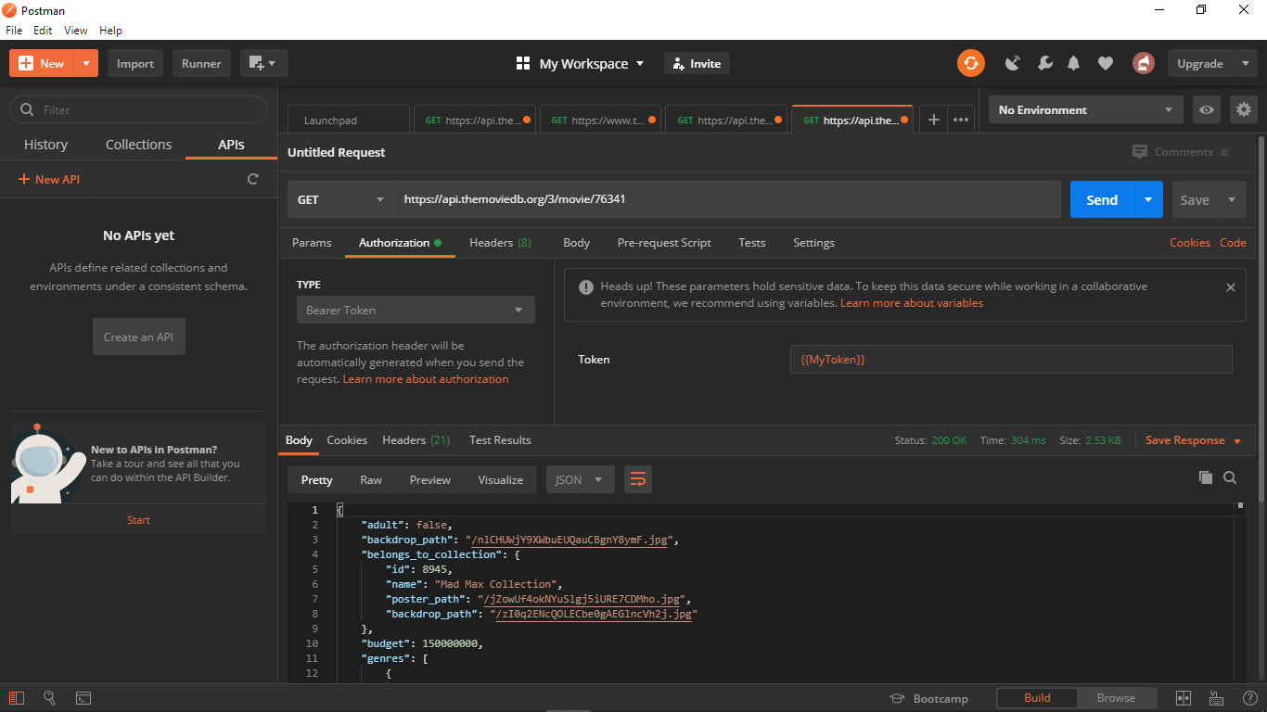
In postman, verify the authorization header with a bearer token as sent to the API. The Token used in the image is a variable I called MyToken setup in the “eye” button:

In the DAL class in the app, I changed the constructor and two methods:
using Microsoft.Extensions.Configuration;
using System;
using System.Collections.Generic;
using System.Linq;
using System.Net.Http;
using System.Net.Http.Headers;
using System.Text.Json;
using System.Threading.Tasks;

namespace GC_Capstone5.Models
{
public class MovieDAL
{
private readonly string _apiKey;
private readonly string _apiBearerToken;

public MovieDAL(IConfiguration configuration)
{
_apiKey = configuration.GetSection("ApiKeys")["MovieAPI"];
_apiBearerToken = configuration.GetSection("ApiBearerTokens")["MovieDbBearerToken"];
}

public HttpClient GetClient()
{
var client = new HttpClient();
client.BaseAddress = new Uri("https://api.themoviedb.org");
client.DefaultRequestHeaders.Authorization =
new System.Net.Http.Headers.AuthenticationHeaderValue("Bearer", _apiBearerToken);
return client;
}

public async Task<string> GetRawJSON(int movieId)
{
var client = GetClient();
var response = await client.GetAsync($"/3/movie/{movieId}?api_key={_apiKey}");
var movieJSON = await response.Content.ReadAsStringAsync();
return movieJSON;
}
public async Task<Movie> GetMovie(int movieId)
{
var client = GetClient();
var response = await client.GetAsync($"/3/movie/{movieId}");
// var response = await client.GetAsync($"/3/movie/{movieId}?api_key={_apiKey}");
var movieJSON = await response.Content.ReadAsStringAsync();
Movie movie = JsonSerializer.Deserialize<Movie>(movieJSON);
return movie;
}
}
}

And finally, the Controller was changed
- to move the API key to the DAL (The key and bearer token are details only the DAL should privately know about.)
- in the Controller constructor, pass the Configuration object to the DAL constructor

